**Experiment - 7**

**Aim: To add Form validations using Javascript.**

Javascript:

JavaScript is the programming language of HTML and the Web.

* JavaScript and Java are completely different languages, both in concept and design.

**Outputs:**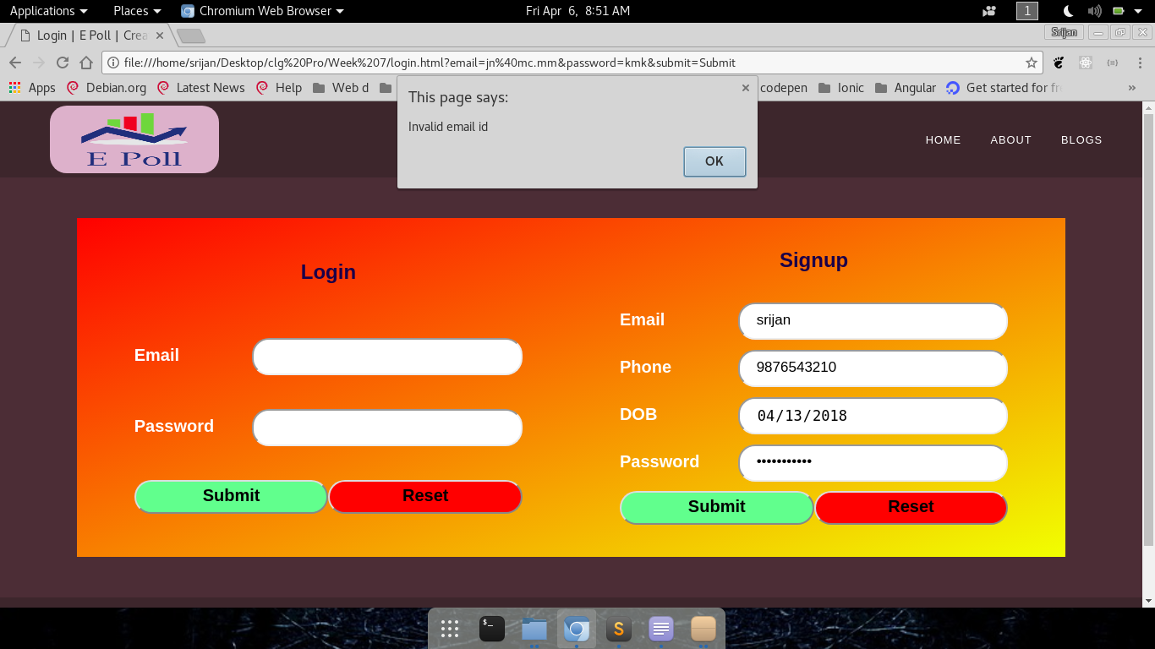

**Email Verification**

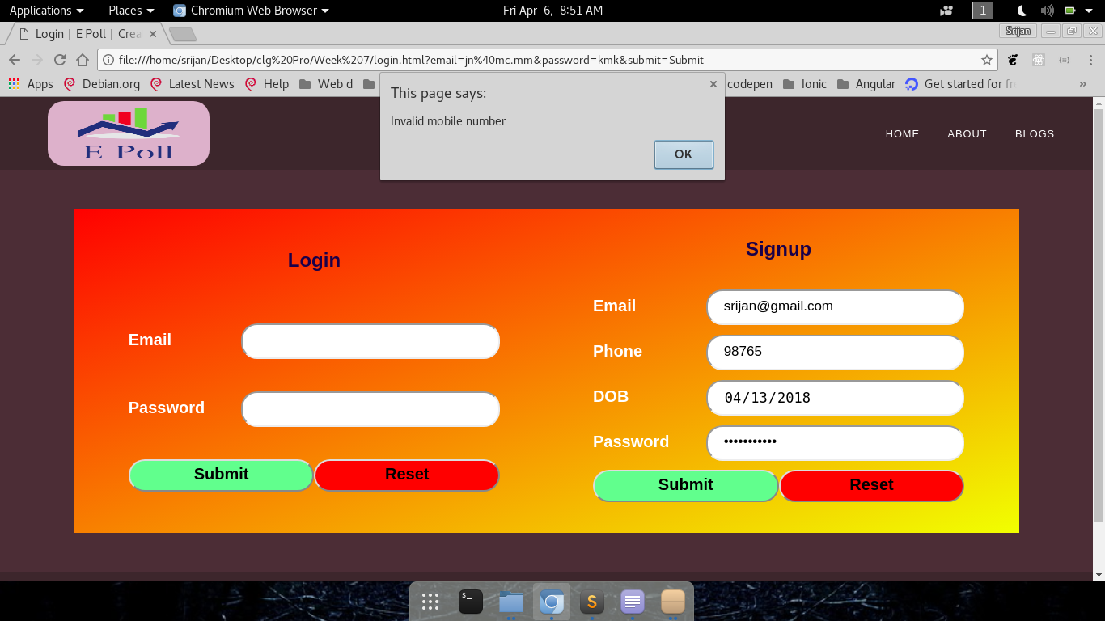

**Mobile Number Verification**

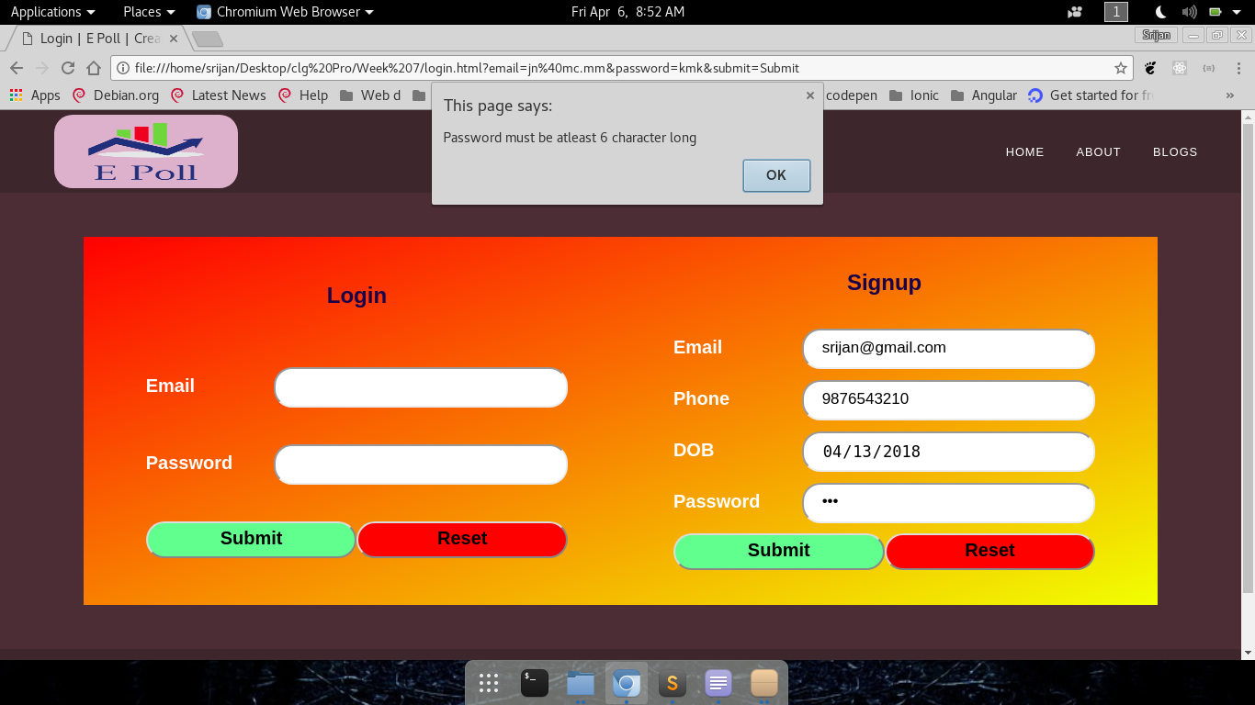

**Password Length validation**